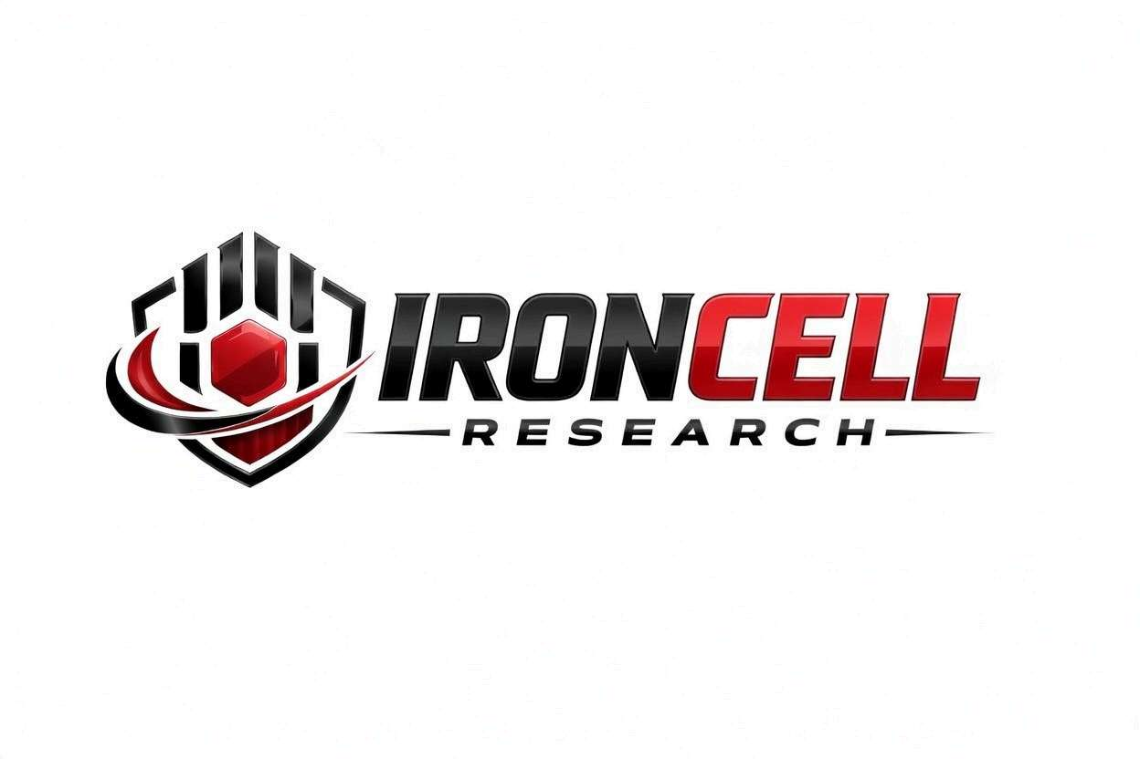
PEPTIDE RESEARCH BRIEF
MOTS-c
Mitochondrial Open Reading Frame of the 12S rRNA Type-c | Exercise Mimetic Peptide

Description, Benefits, Dosage & Research Overview

Iron Cell Research
IronCellResearch.com
For Research Use Only


Compound Overview
Compound Name | MOTS-c (Mitochondrial ORF of the 12S rRNA Type-c)
Classification | Mitochondrial-Derived Peptide (MDP)
Amino Acid Sequence | MRWQEMGYIFYPRKLR (16 amino acids)
Molecular Weight | 2174.7 g/mol
Origin | Encoded by mitochondrial DNA (12S rRNA gene)
Biological Half-Life | Estimated 4-12 hours
Purity | Greater than or equal to 99%
Storage | Lyophilized, -20C, protected from light and moisture
Research Status | Active preclinical & early clinical research

Description
MOTS-c is a mitochondrial-derived peptide first identified by Dr. Changhan David Lee and colleagues at the University of Southern California in 2015. It has been described as an exercise mimetic due to its ability to activate AMPK and reproduce many metabolic benefits of physical exercise.
MOTS-c translocates to the nucleus in response to metabolic stress, where it regulates adaptive nuclear gene expression through interactions with antioxidant response elements (AREs). Endogenous MOTS-c levels decline with age and are significantly higher in physically active individuals.

Mechanism of Action

AMPK Activation & Metabolic Regulation
MOTS-c activates AMPK through interference with the folate-methionine cycle, leading to accumulation of AICAR, an endogenous AMPK activator. This triggers enhanced glucose uptake, increased fatty acid oxidation, and inhibition of lipogenesis.

Nuclear Translocation & Gene Regulation
Under metabolic stress, MOTS-c translocates from mitochondria to the nucleus where it interacts with antioxidant response elements to regulate genes involved in cellular stress adaptation, glutathione metabolism, and mitochondrial homeostasis. This represents novel retrograde signaling.

Folate-Methionine Cycle Modulation
MOTS-c modulates de novo purine biosynthesis by inhibiting the folate-methionine pathway, influencing one-carbon metabolism, methylation reactions, and nucleotide synthesis.

Insulin Sensitization & Glucose Homeostasis
MOTS-c enhances glucose uptake in skeletal muscle through AMPK-dependent GLUT4 translocation and improved insulin signaling. It reduces hepatic glucose output and improves whole-body glucose disposal independent of body weight changes.

Research Benefits

Metabolic Health & Obesity
- Weight Management: Prevents diet-induced obesity in mouse models without changes in food intake.
- Fat Oxidation: AMPK activation promotes fatty acid beta-oxidation in muscle and liver.
- Metabolic Syndrome: Improves hyperglycemia, insulin resistance, dyslipidemia, and visceral adiposity.

Exercise Performance
- Exercise Mimetic: Reproduces metabolic adaptations of exercise including enhanced glucose utilization and mitochondrial biogenesis.
- Endurance: Significantly improves running endurance in aged mouse models.
- Skeletal Muscle: Preserves muscle mass and function, counteracting sarcopenia.

Anti-Aging & Longevity
- Healthspan Extension: Late-life treatment improves physical function and metabolic health.
- Stress Resistance: Enhances cellular resilience through ARE-mediated gene regulation.
- Mitochondrial Quality: Promotes mitophagy and biogenesis for healthy mitochondrial populations.

Bone & Skeletal Health
- Osteoporosis Prevention: Protective effects against bone loss in ovariectomized mouse models.
- Bone Formation: Promotes osteoblast differentiation through AMPK-dependent pathways.

Inflammatory & Immune Regulation
- Anti-Inflammatory: Reduces TNF-alpha, IL-6, and IL-1beta in metabolic inflammation models.
- Immune Modulation: Modulates T-cell differentiation with implications for immunosenescence.

Dosage & Administration
The following dosage information is provided for research reference purposes only.
Protocol | Dose Range | Route | Frequency
Low / Introductory | 5 mg | SubQ Injection | 3x per week
Standard | 10 mg | SubQ Injection | 3-5x per week
Advanced / Loading | 10-15 mg | SubQ Injection | Daily x 5 days/week
Maintenance | 5-10 mg | SubQ Injection | 2-3x per week

Reconstitution Guidelines
Solvent | Sterile bacteriostatic water
Reconstitution | 1-2 mL BAC water per vial
Mixing | Gently swirl until dissolved, do not shake
Storage | Refrigerate at 2-8C, use within 21 days
Injection Site | Subcutaneous (abdomen, thigh), rotate sites
Timing | Morning administration preferred (aligns with metabolic rhythm)

Safety Profile
MOTS-c is an endogenously produced peptide with a favorable safety profile:
- General Tolerability: Excellent tolerability in animal models with no significant adverse effects at research doses.
- Injection Site: Mild, transient reactions possible at subcutaneous injection sites.
- Hypoglycemia Risk: Monitor when used with concurrent anti-diabetic medications.
- Drug Interactions: May interact with metformin and other AMPK activators.
- Cancer Considerations: While anti-tumor properties observed in some models, caution warranted with active malignancies.
- Pregnancy & Nursing: Insufficient safety data; use not recommended.

Key References
- Lee C, et al. The Mitochondrial-Derived Peptide MOTS-c Promotes Metabolic Homeostasis and Reduces Obesity and Insulin Resistance. Cell Metabolism. 2015;21(3):443-454.
- Kim KH, et al. The Mitochondrial-Encoded Peptide MOTS-c Translocates to the Nucleus to Regulate Nuclear Gene Expression. Cell Metabolism. 2018;28(3):516-524.
- Reynolds JC, et al. MOTS-c is an Exercise-Induced Mitochondrial-Encoded Regulator of Age-Dependent Physical Decline. Nature Communications. 2021;12(1):470.
- Ming W, et al. MOTS-c Suppresses Ovariectomy-Induced Bone Loss via AMPK Activation. Biochemical and Biophysical Research Communications. 2016;476(4):412-419.
- Zhai D, et al. MOTS-c Peptide Increases Survival and Decreases Bacterial Load in Mice Infected with MRSA. Molecular Immunology. 2017;92:151-160.
- Lu H, et al. MOTS-c Regulates Adipose Homeostasis to Prevent Ovariectomy-Induced Metabolic Dysfunction. Journal of Molecular Medicine. 2019;97(4):473-485.
- Kumagai H, et al. MOTS-c Reduces Myostatin and Muscle Atrophy Signaling. American Journal of Physiology. 2021;320(4):E680-E690.

Contact & Information
Company | Iron Cell Research
Website | IronCellResearch.com
Email | orders@ironcellresearch.com
Product Support | Available via website contact form

Disclaimer
This document is intended for informational and research purposes only. MOTS-c is sold as a research compound and is not intended for human consumption. The information provided herein does not constitute medical advice, diagnosis, or treatment recommendations. All research applications should comply with applicable institutional, local, and federal regulations. Iron Cell Research makes no claims regarding the therapeutic efficacy of MOTS-c for any medical condition. Researchers should consult with qualified healthcare professionals and institutional review boards before initiating any research protocols involving human subjects.
Iron Cell Research - For Research Use Only


